Propositions

OnFest

Course: ProP

Group: 31

Dimitar Parpulov - 3207358

Diqin Yang - 3324087

Dongdong Ke - 3338207

Phat Tran - 3335968

1. Home

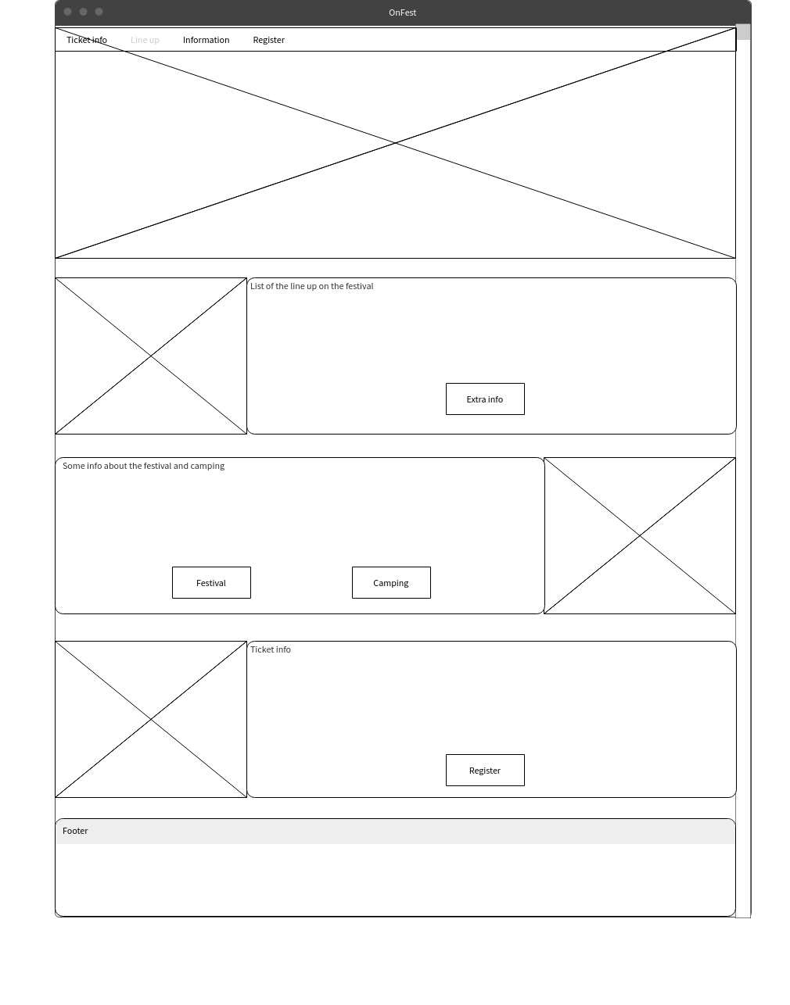

1. Home page visual design

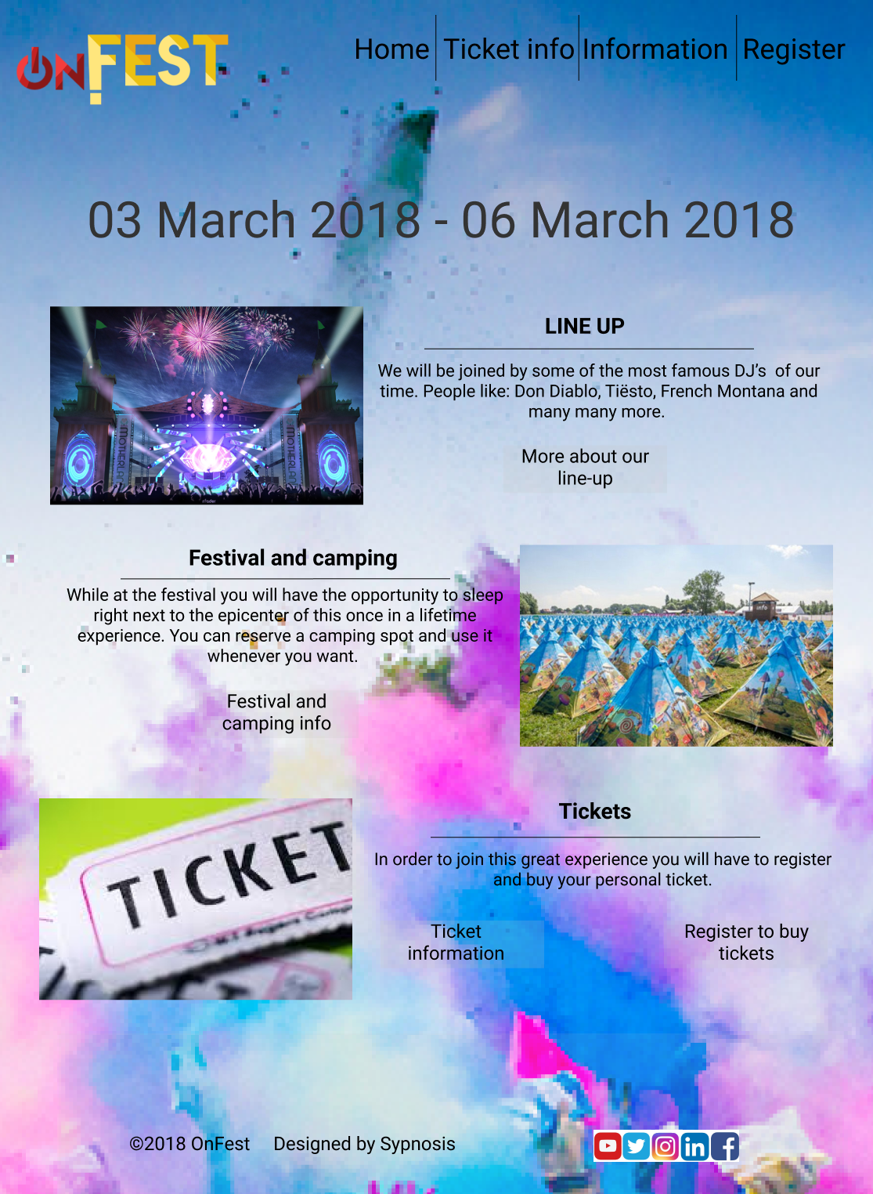

1. Account information wireframe

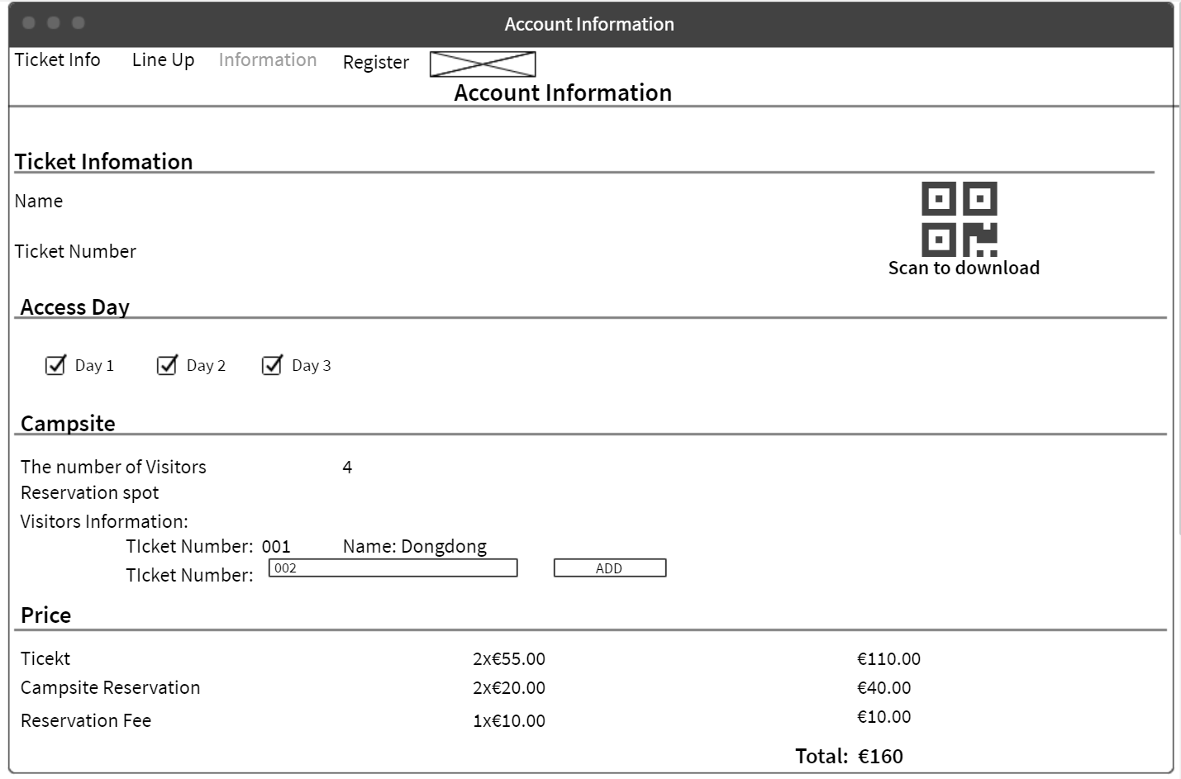

1. Account information visual design

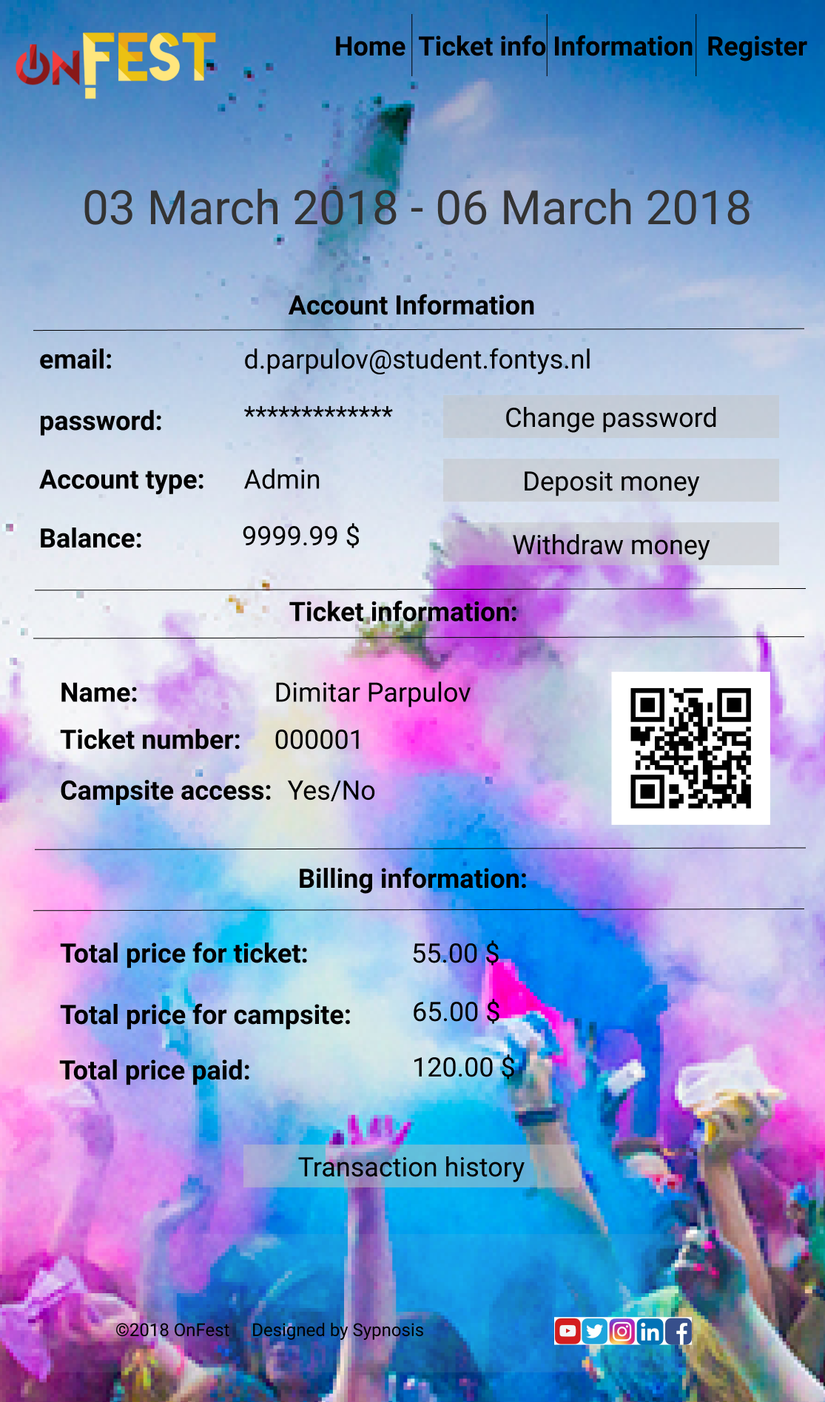

Here are the rest of the Wireframes if you have time you can check them and at the bottom of the document are the visual designs of the applications you can also check them and say if they are good to go or we should change them.

1. Register

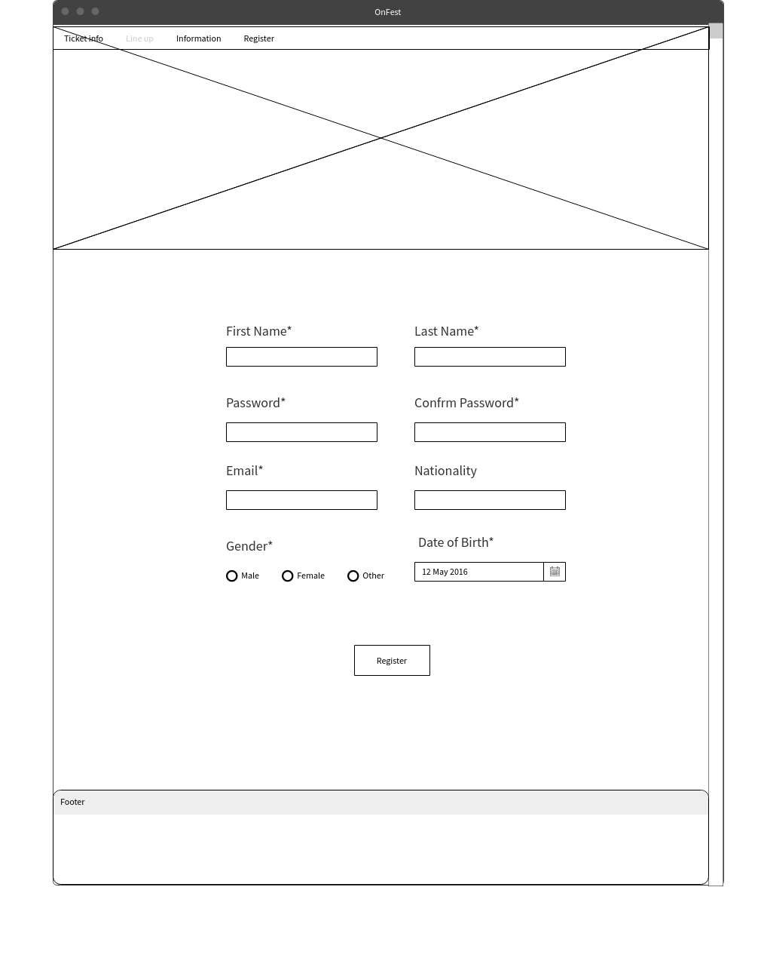

1. Log in

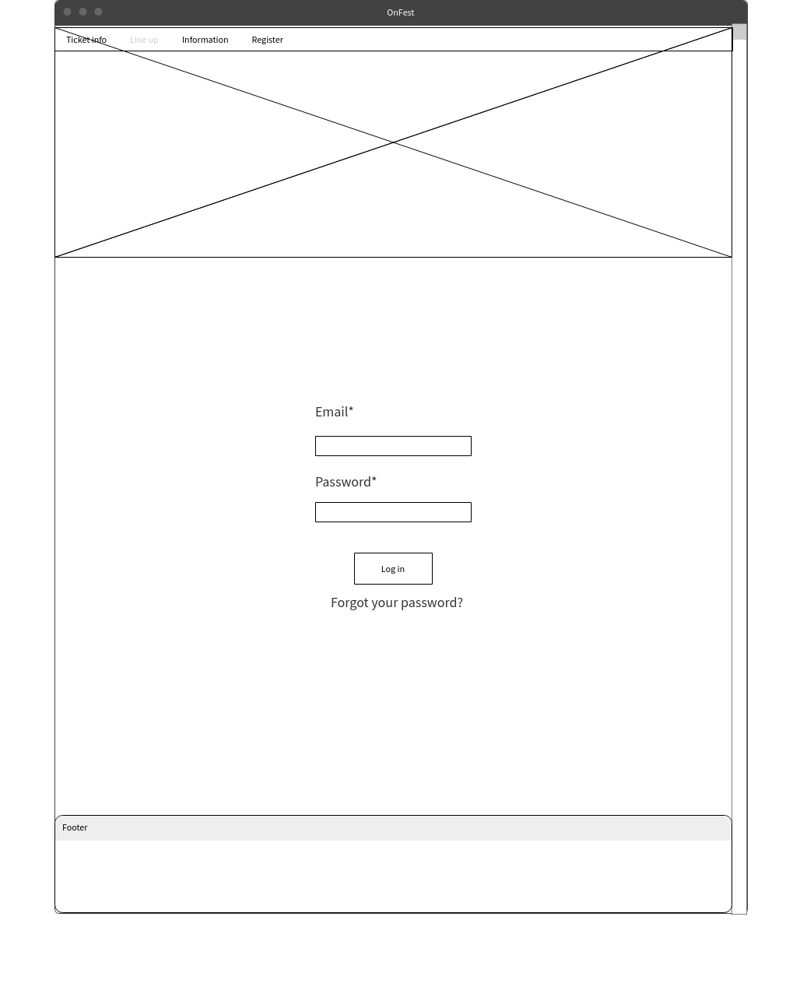

1. Information

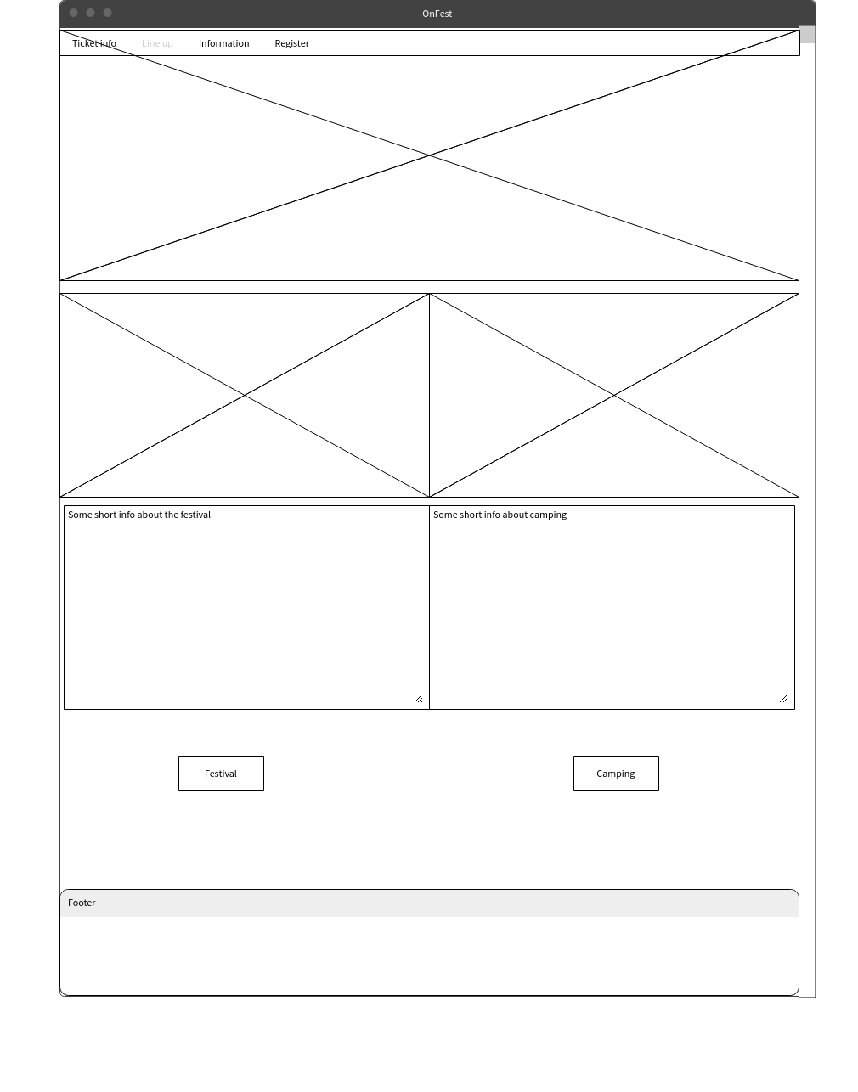

1. Line up

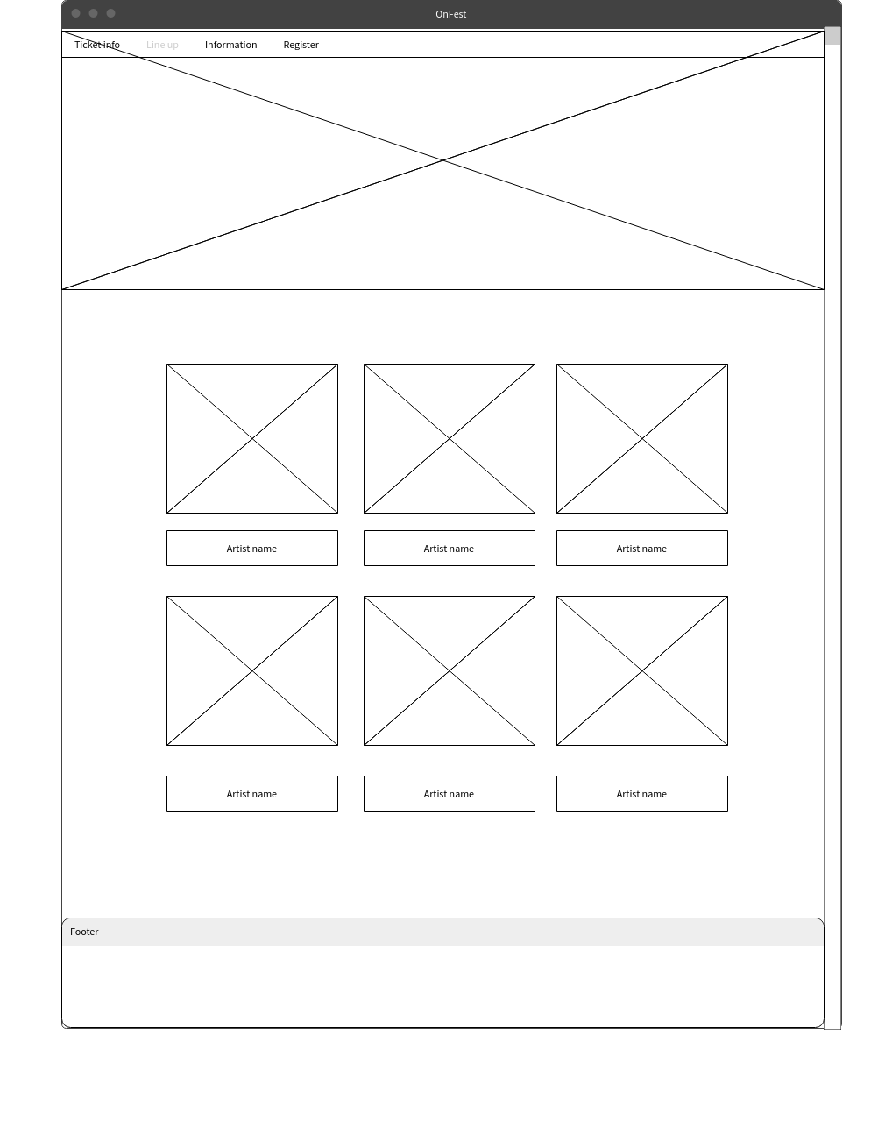

1. Deposit

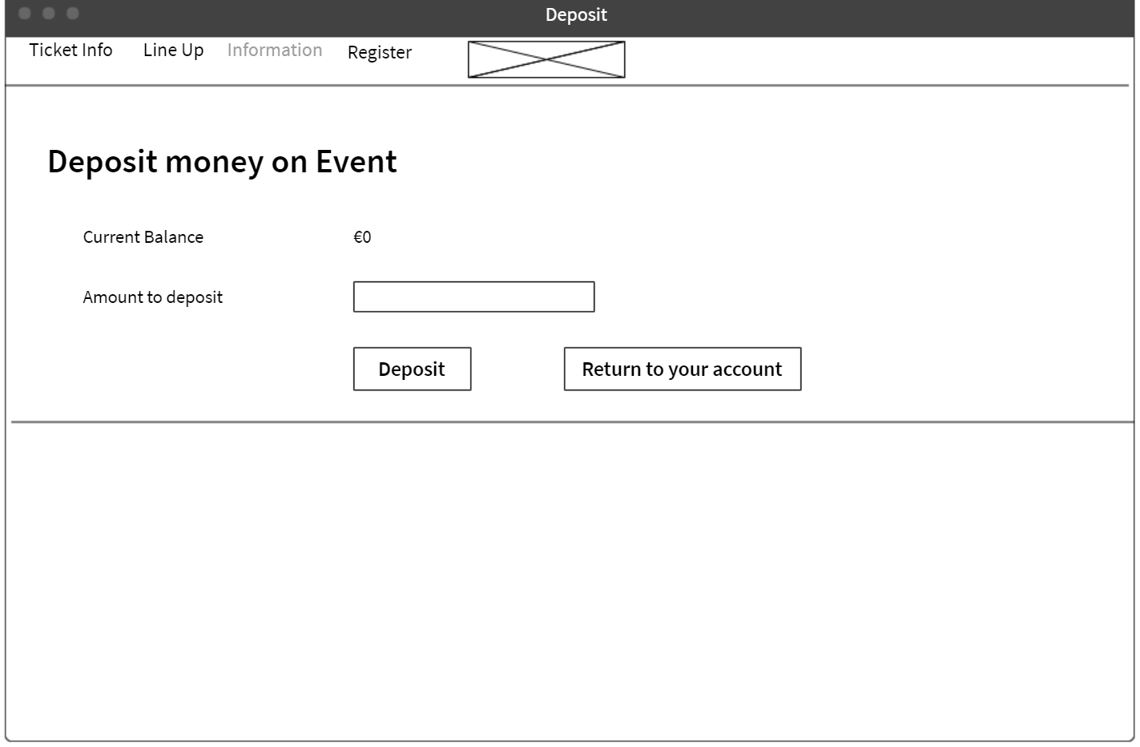

1. Sitemap

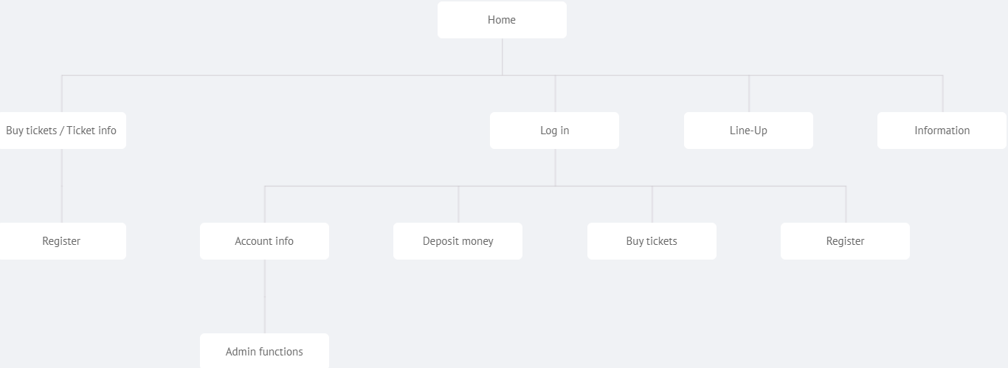

1. Applications GUI’s Version1

* Choose which application you are going to use

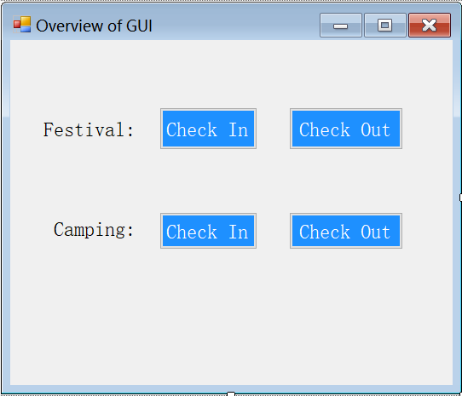

* Festival check in

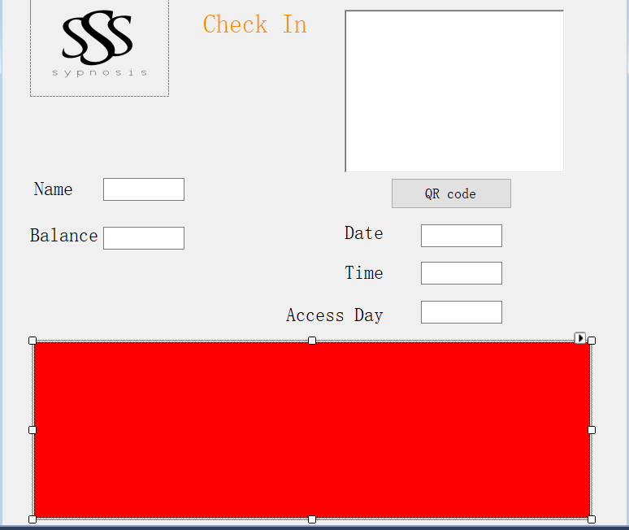

* Festival check out

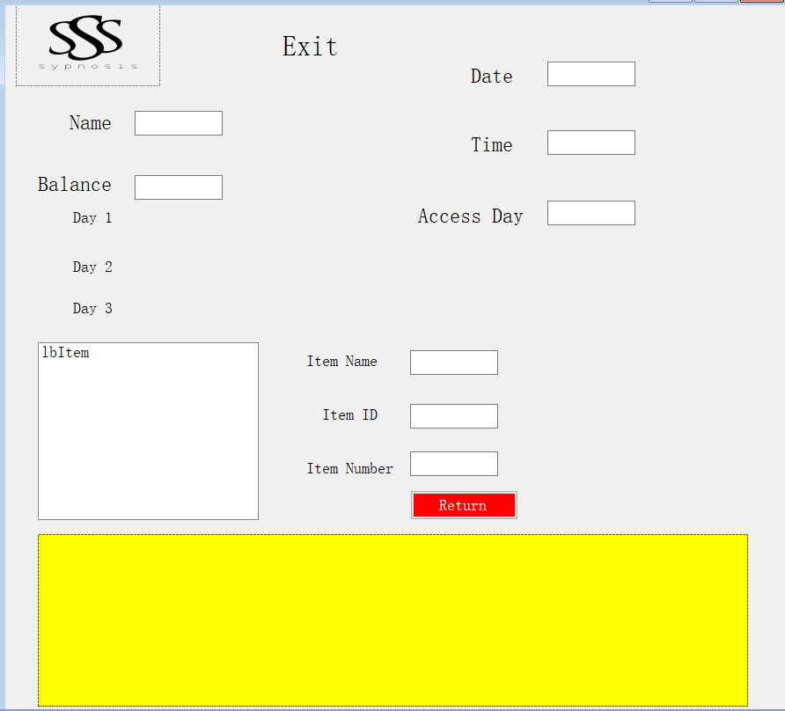

* campsite check in

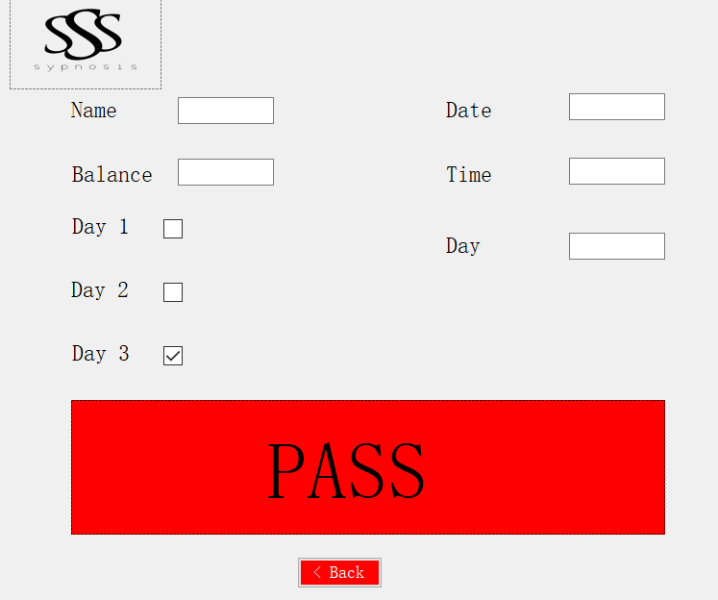

* choose which shop you are going to use

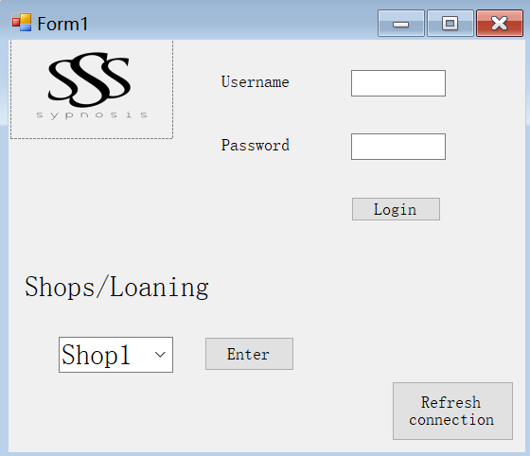

* Shops GUI

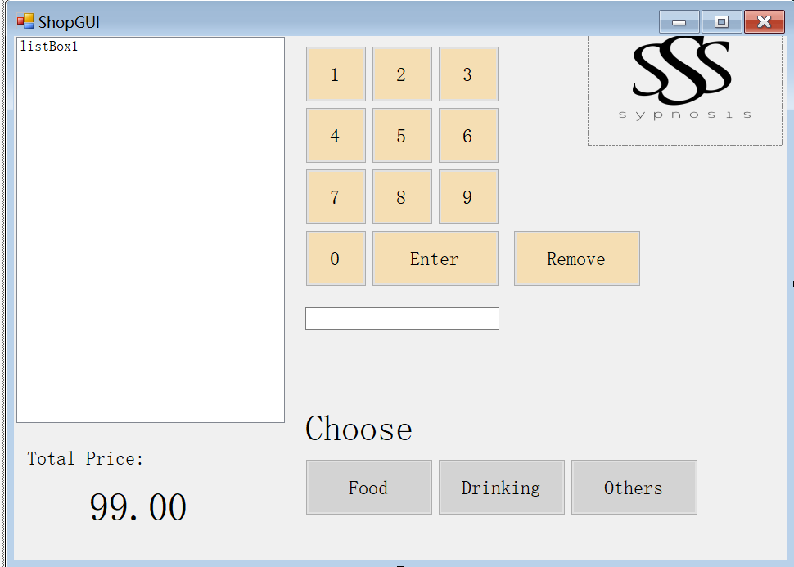

* Choose food

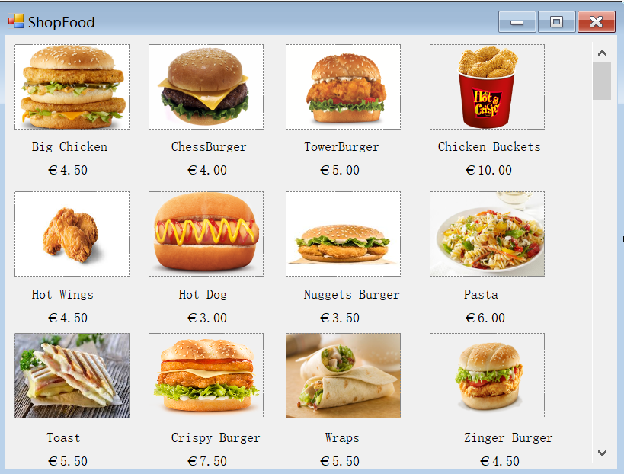

* Choose drinks
* 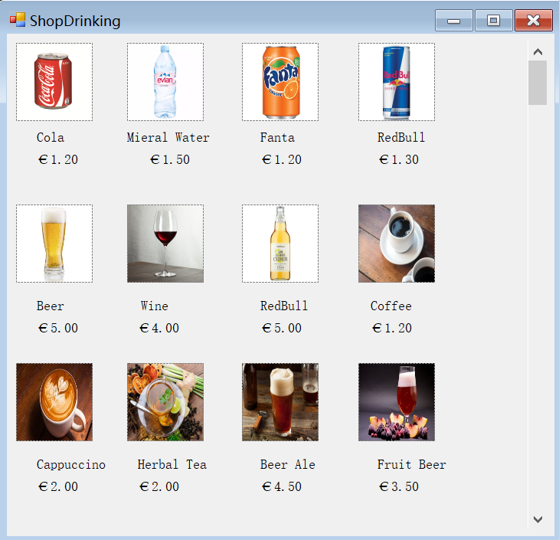
* We will also add other items like advertisement t-shirts. The loaning stand apps will have similar design to the shop apps.

Applications GUI’s Version2

-Add logo and button “Reconnect”

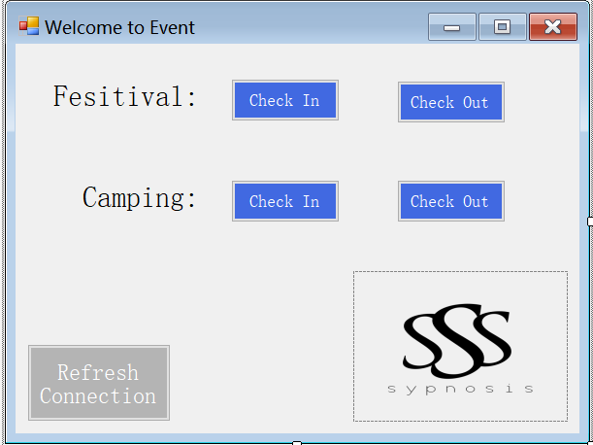

- Festival check in color and font changed.

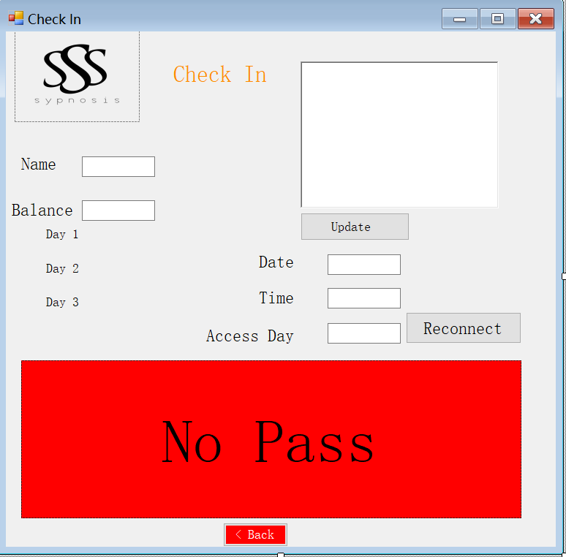

-Festival check out. “No Pass” text added and color changed.

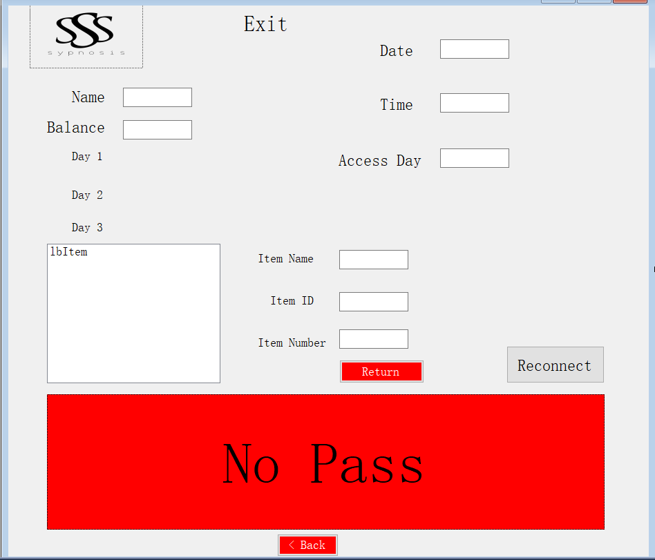

-Camping check in. “No Pass” text added and color changed.

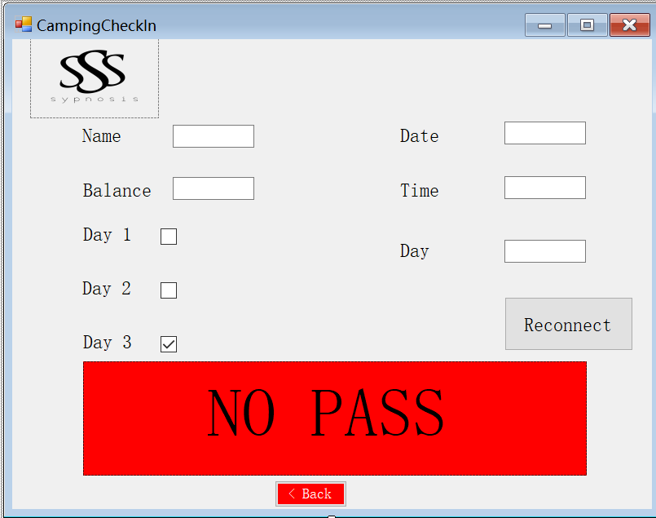

-Choose shops

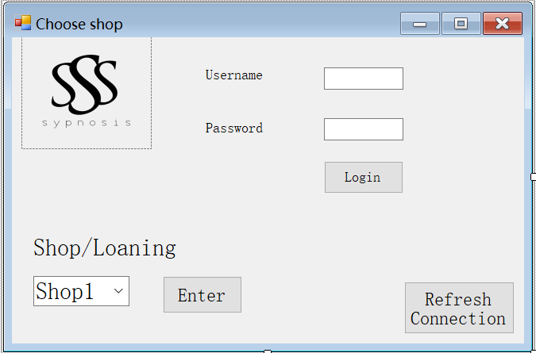

-Shops

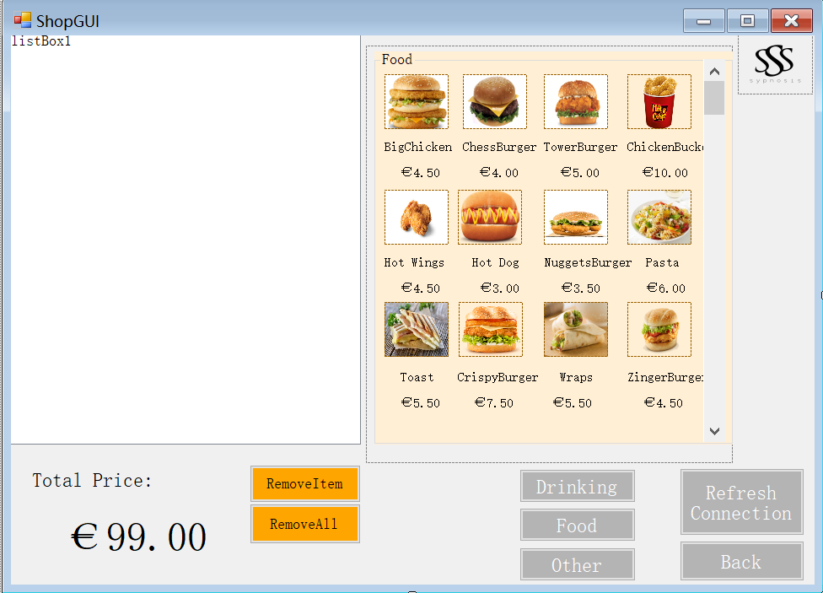

-Loaning Stand

